1:1 Operations Manager

Generally business users want to change small things like description of product or its expiration date. Most of the times in enterprise applications these changes cost so much so here in this case 1:1 operations manager empowers business users to make these changes by themselves.

Pega 1:1 Operations manager provides a guided process for managing changes to decisioning artifacts. Basically business users determine what must be the changes that need to be done in a collaborative and unified way.

In one to one customer engagement project, changes are classified into 2 types

* Enterprise changes
* Business changes

Enterprise changes are those which developers make to Pega application.

Developers make these changes in the development environment. Changes to the application are pushed to other environments through the enterprise-change pipeline managed by the Pega Deployment Manager™.

Business changes are made by BO team in the BOE environment. Examples are Updating an action creating a new treatment

The business content team uses the 1:1 Operations Manager portal to initiate changes in the business operations environment.

Changes from the business operations environment are pushed to the development environment and from there to other environments through the business change pipeline.

It is a best practice to have a single team for managing business changes at the organization level typically called as business operations team.

It includes 3 types of users

* Business Users
* Team lead
* NBA Specialists

BU- they create or submit a change request in 1:1 operations manager application

Team Lead- team lead reviews and manages priorities for change requests

NBA Specialist- they work on tasks to implement the business changes requested by business users.

Now next comes lifecycle of a change request

Change request has 4 stages

* Plan
* Build
* Test
* Deploy
* Plan
  + A business user creates the change request.
  + **Key**information about the change is captured from the business user directly into Pega 1:1 Operations Manager.
  + The team lead quickly **plans** and prioritizes the request so that the operational team can focus on more high-value work.
* Build
  + The operations team **builds** the next-best-action artifacts using a simple, guided process.
  + Next-best-action specialists translate the change request details into corresponding next-best-action artifacts in Pega Customer Decision Hub.
  + The system automatically creates or updates the corresponding artifacts.
* Test
  + The system recommends that the next-best-action specialists verify and test the generated or modified artifacts to ensure that the change meets the business’ expectations.
  + Changes can be tested in-context to reduce QA cycles.
* Deploy
  + The team lead approves the change request and transfers it to the team responsible for deploying the changes to the production environment.
  + Pega Deployment Manager enables the deployment team to safely **deploy** the changes to a production pipeline.

From BOE you can make 2 types of changes to the CDH

* High volume requests
* Low volume requests

Currently three types of change requests are supported. Selecting the right change request category initiates the appropriate change management process flow.

* Create new action
* Updating a new action
* Then

Use the **Create new action** category when submitting a request to create a new action.

Use the **Update existing action** category when submitting a request to update an existing action.

If the change request is neither creating a new action nor updating an existing action, then you can select the **Other** category. This case type is best suited to making changes that are not related to a single action, such as editing engagement policies, changing arbitration rules, and so on.

A change request with **Other as its** category is assigned to a team lead, who then adds one or more tasks from the predefined list of objectives according to the business requirement. These tasks are typically assigned to an NBA designer.

Revision Management

If the required business change is beyond the scope of the three change request types then team lead initiates the change by creating a new revision in the revision management section of 1:1 Operations Manager.

Then, in the Customer Decision Hub portal, the team lead creates a change request within the revision created in the 1:1 Operations Manager.

One of the main generative AI features available in 1:1 Operations Manager is Automated insights.

**Automated insights** combine the power and features of Pega Value Finder analysis with Pega GenAI, to detect underperforming Next-Best-Actions and provide actionable recommendations for improving actions and treatments. The suggestions are available in 1:1 Operations Manager, in the **Automated Insights** section.

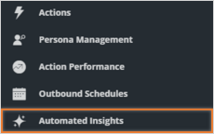

After you successfully create the change request as a Business User, log in as a Team Lead and prioritize the change request.

The next step is to complete the action build task. Log in as an NBA Specialist and check if you see the Design web treatment tasks for each of the newly created treatments.

Assign the Design web treatment tasks to yourself and complete them one by one.

From this point, the NBA Specialist, the Team Lead and the Revision Manger can finish the process until the new changes are deployed to production.

Basically from the portal you can create from a request category indicates the type of change.

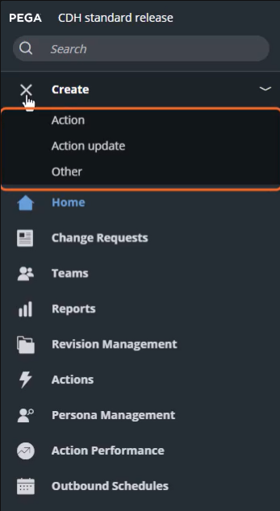

Either you can create from the pre existing actions or you can create custom action.

Now the change request has Change request ID and the change request is currently under Plan Stage

There are 4 things to complete

First one is Define attributes where you need to enter the name and associate it with business issue and business group. These can be changed later by NBA Specialist

Then the 2nd thing to complete is Availability

Next define the journey stage and

4th step is to define engagement policy section, there are two options to define engagement policy details

1st option is Describe changes where you can describe the requirements using business language and NBA specialist is responsible for implementing these requirements, in the build stage.

You can also use the condition builder to see 4 categories and define eligibility rules for the given criteria i.e applicability suitability eligibility and then we can use the Contact policy to avoid over exposure of actions.

The last one is Channel is you need to give the channel in which the action is presented.

Finish the task

Prioritize a change request

Business user submits a change request

As team lead we are responsible for the two tasks in the Plan Stage.

The next stage is to assign peer reviewers to verify the engagement policy defined in the build stage

And we must rank the change request first.

Complete the task

NBA specialist are responsible for the tasks.

As an NBA Specialist, you can access the change request that is in the queue on the **Change requests** landing page. Open the request. As an NBA Specialist, you have various build tasks to complete that the system generated to implement the business requirements that the business user defined

Now, as the Team Lead, open the change request to verify it. Approve the change request to promote it to the **Deployment** stage.

Final thing is to push changes to production

As a revision manager you need to push the changes made by the business operations team to the pipeline deployment.

We can access the change request by using the revision management tab

In the navigation pane.

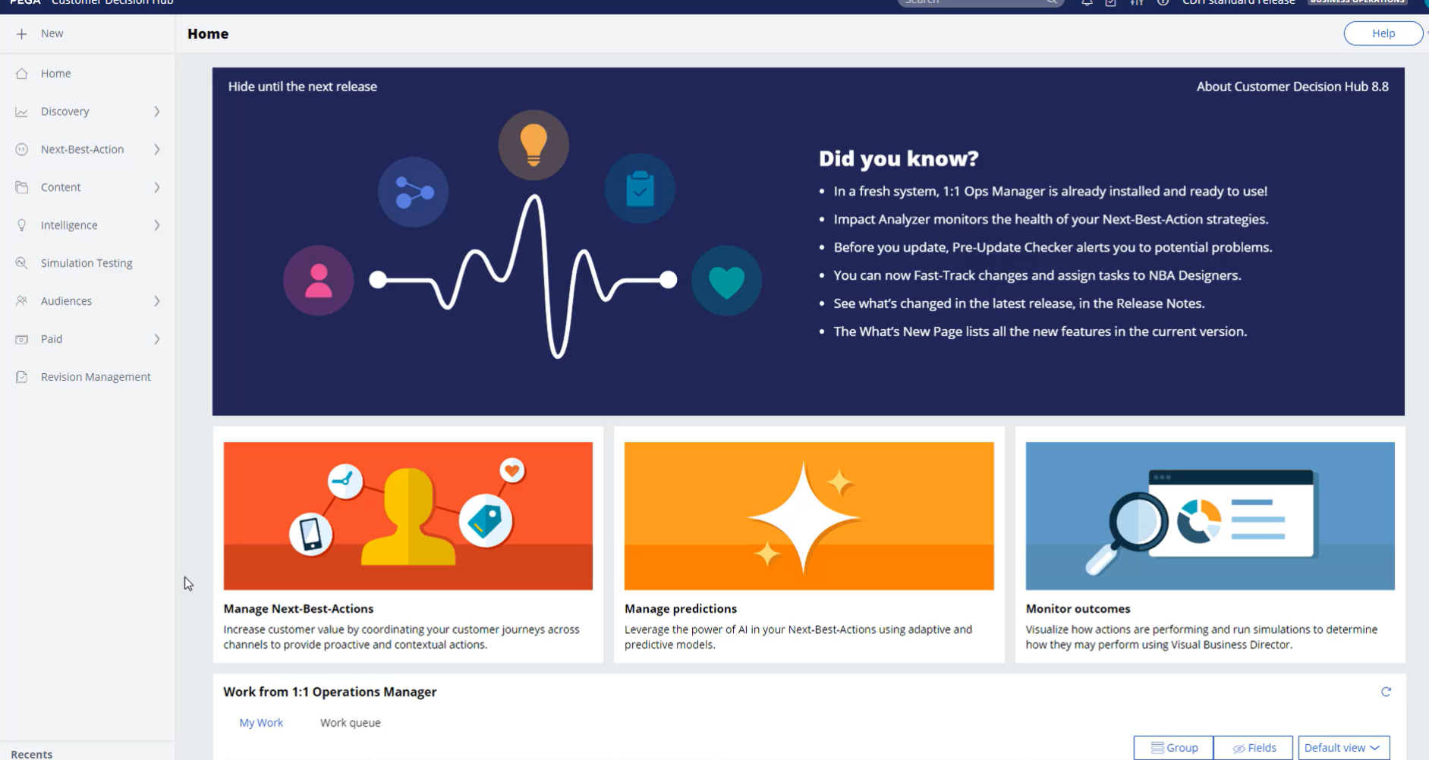

Then you will find current revision then open the revision and click on actions and 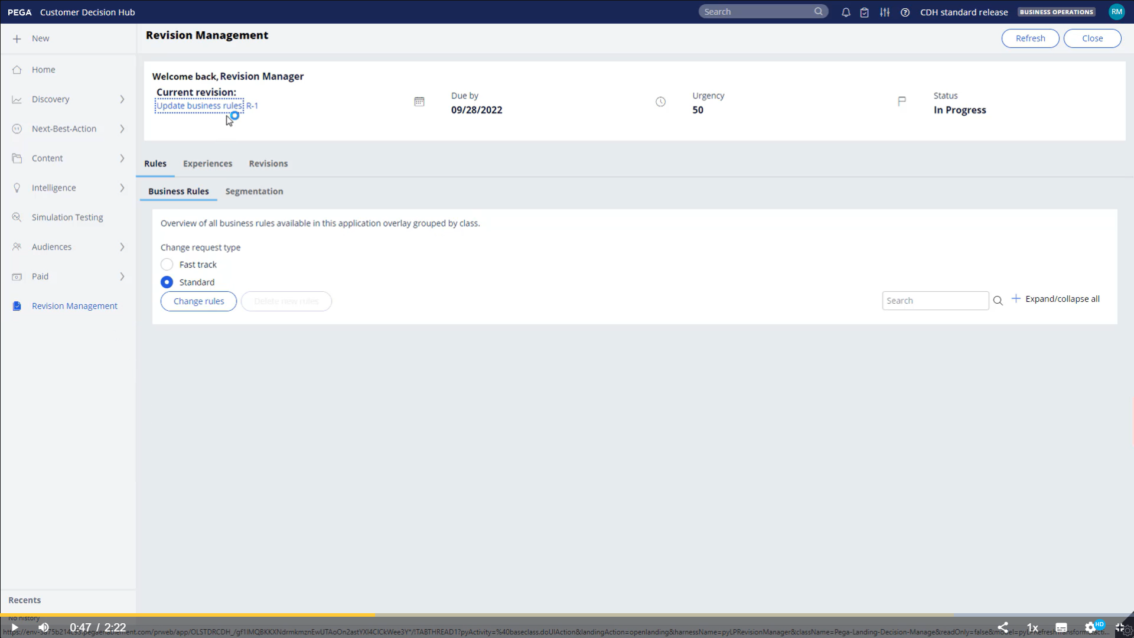

Then you need to deploy the revision

Then you need to give a comments and then deploy the revision

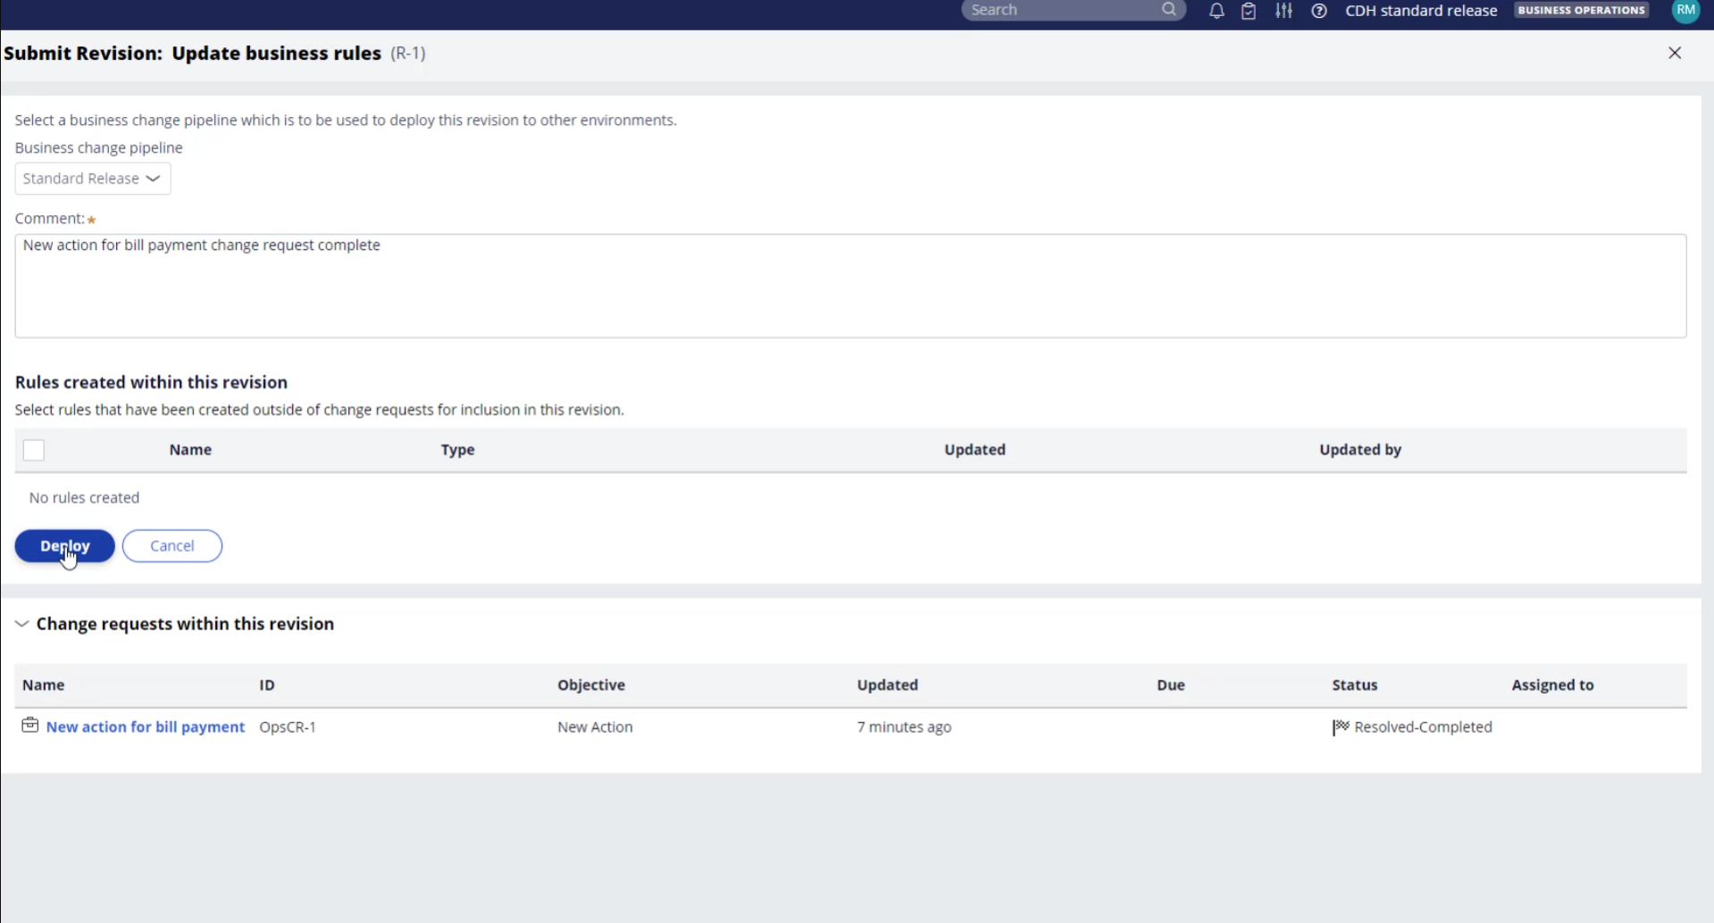

Then it will show queued for the deployment

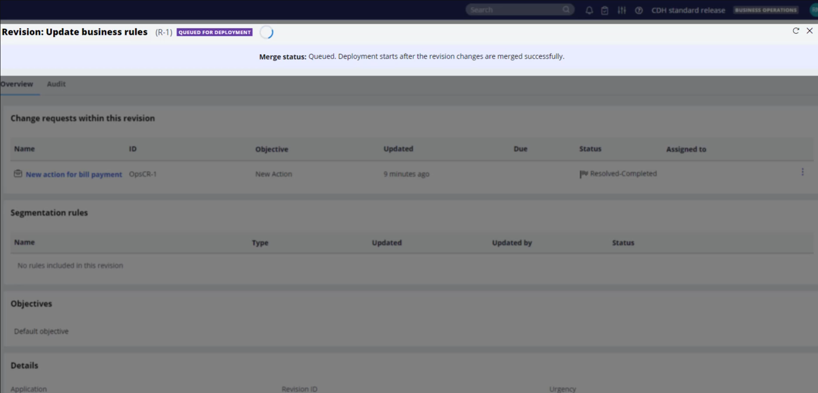

And status will change to deploying and then it will get deployed and then we need to deploy it and then test and activate

And then we can test and activate revision and activate for all operators and then submit it to the operator.

And then click on complete revision and then the status is deployed.

Majorly there are five steps involved

1. The business user starts the process by defining the change request.
2. Then, the team lead prioritizes the change requests that are received.
3. The NBA Specialist then configures the change request and submits it back to the team lead.
4. The team lead promotes the change request for deployment.
5. And finally, the revision manager deploys the revision.

In addition to single action updates, the **Action update** change request type enables you to perform bulk updates on always-on actions. A bulk edit feature is a valuable option when you need to implement a specific change across multiple actions.

And also we need to give steps for updating existing actions

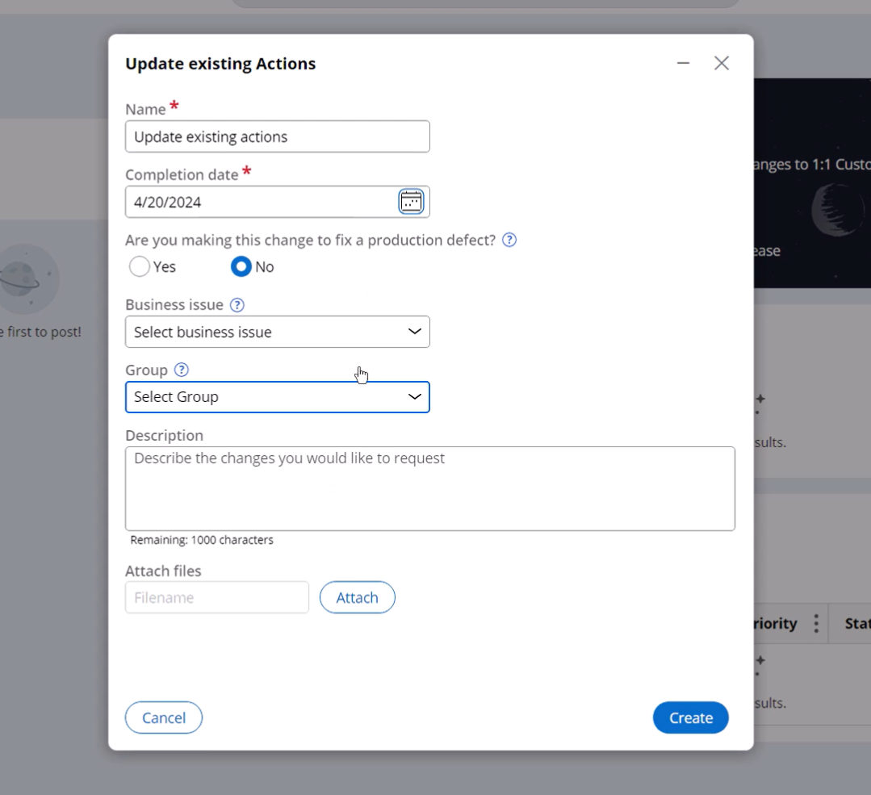

And also there are 3 stages to complete these actions

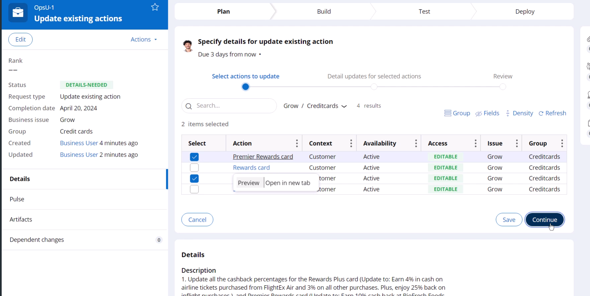

After business user updates team lead needs to take up the reaction which is the change request

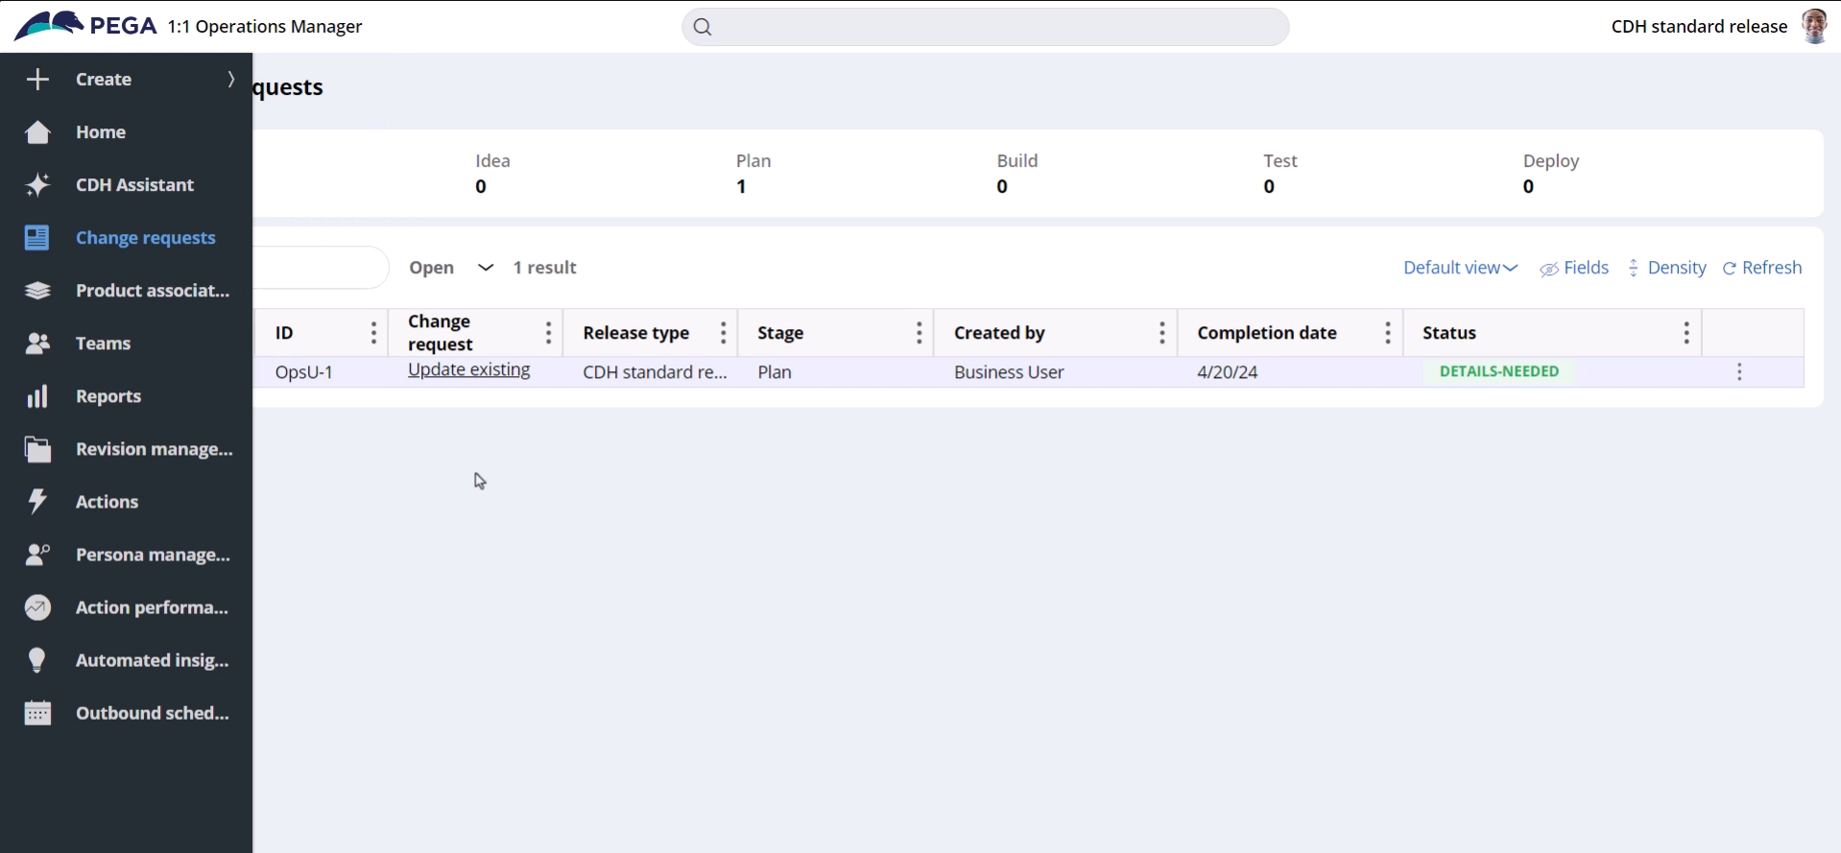

Then team lead needs to review the things and prioritize the change requests

And then the revision request is done and then deployed.

Implementing a Fast release revision

The implementation of the fast-track change is similar to a standard business change. During the deployment process, the revision manager switches to the CDH fast release application to deploy the fast-release revision through the **fast release pipeline**.

Like a standard revision, a fast-release revision can also have multiple change requests. You can track the fast-track change requests in the **CDH fast release** section of Revision Management in Pega 1:1 Operations Manager.

The **CDH standard release** section displays the existing standard revision. You can access the list of change requests that are associated with a revision. The **On hold** section lists the change requests that are put on hold.